


SIMATS ENGINEERING
Saveetha Institute of Medical and Technical Sciences
Chennai- 602105
Student Name: Roshan K Reg. No.:192425014
Course Code: CSA1215 Slot: A
Course Name: Computer Architecture
Course Faculty: Dr. Santhakumar Devaraj
Project Title: Design and implementation of an adaptive cache memory simulator for intelligent performance optimization

Module Photographs:

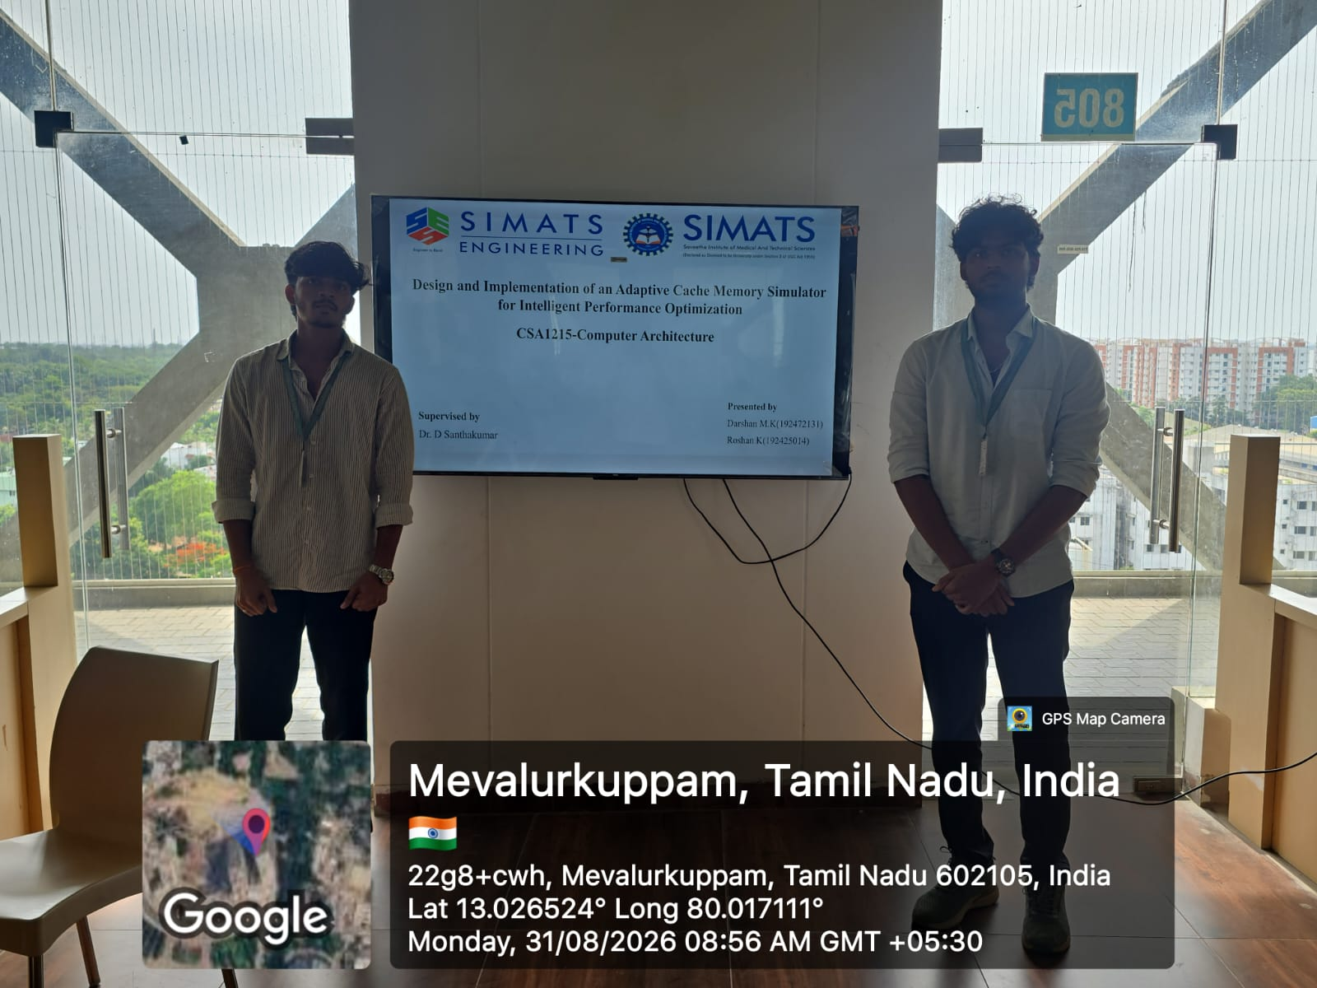
Project Description: This project develops a cache memory simulator that dynamically optimizes cache performance based on memory access patterns. It analyzes cache hits, misses, and access time to reduce delays and improve overall system performance.
This module focuses on intelligently improving cache performance by analyzing the results and memory access patterns obtained from the simulation. It monitors the frequency and sequence of memory requests to identify patterns such as frequently accessed data, repeated accesses, and high cache-miss situations. Based on this analysis, the module dynamically selects or adjusts suitable cache management and replacement strategies to achieve better performance. It compares different cache configurations and determines which strategy provides a higher hit ratio and lower memory access time for a particular workload. The module continuously evaluates cache behavior and adapts its optimization approach according to changing access patterns. The main objective is to reduce cache misses, minimize memory latency, improve cache utilization, and increase overall processing efficiency. Finally, the module presents performance comparisons before and after optimization, demonstrating the effectiveness of the adaptive cache management technique.

Student Signature Guide Signature

